SOUTH POINTE HIGH SCHOOL
2021 BASKETBALL
STATE CHAMPIONSHIP GEAR

NAME:

TOTAL DUE: PAID:

PHONE:

ORDERS DUE BY
CHECKS MADE OUT TO STALLION CLUB AND MUST HAVE DRIVER’S LICENSE AND PHONE NUMBER ON CHECK. DROP OFF IN ATHLETIC OFFICE
ORDERS WILL BE AVAILABLE FOR PICKUP AFTER
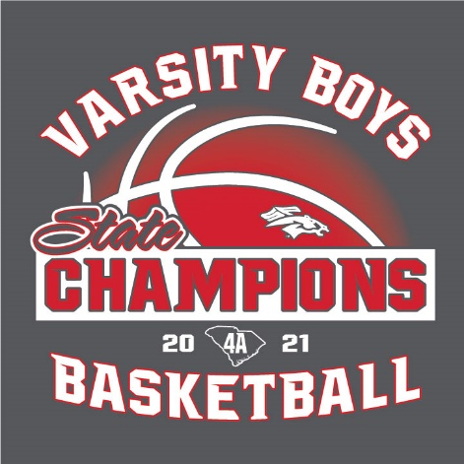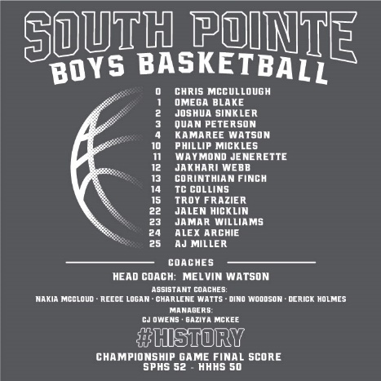
Complete Playoff Roster on Back
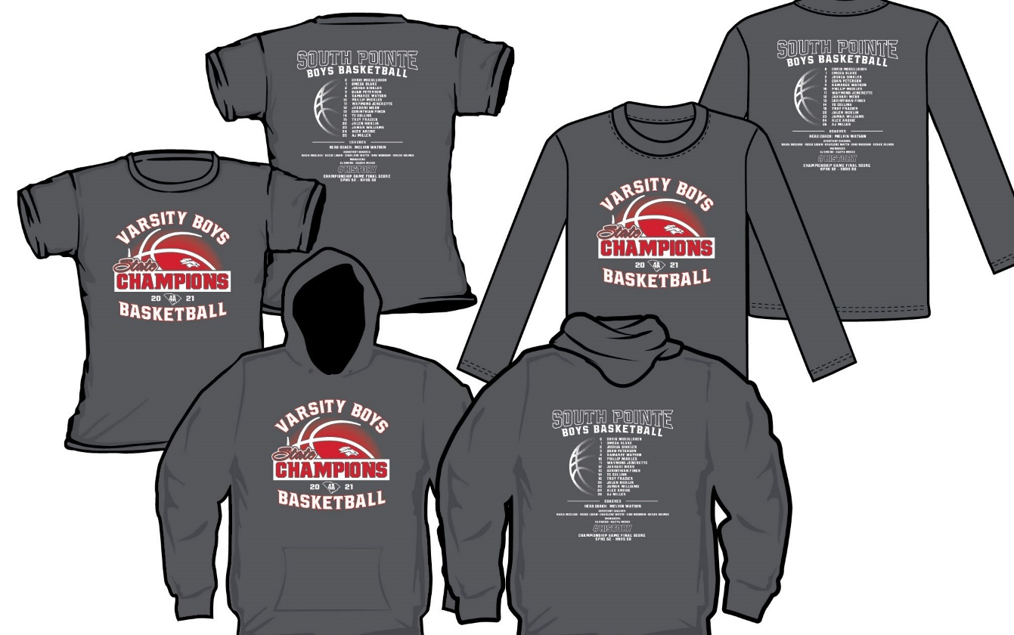
SHORT SLEEVE T-SHIRT
XS___ S___ M____ L____ XL____ $15.00
2XL____ 3XL_____ 4XL____ $21.00
HOODIE - GREY
XS___ S___ M____ L____ XL____ $30.00
2XL____ 3XL_____ 4XL____ $35.00
LONG SLEEVE T-SHIRT
XS___ S___ M____ L____ XL____ $18.00
2XL____ 3XL_____ 4XL____ $21.00
SOUTH POINTE HIGH SCHOOL
2021 BASKETBALL
STATE CHAMPIONSHIP GEAR

