APA 7th Edition Resources
The Writing Center has made a useful video that can help guide students to the best resources to support them with the APA 7th Edition updates.
In order to tell your students about this great resource, please post the below announcement in your class. You can copy and paste the announcement right into your classroom announcements by clicking on the “HTML Editor,” and using the HTML code as shown below:
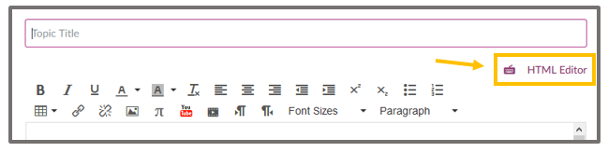

Announcement Message as it Will Appear When Using the HTML Code Below:

Subject: APA 7th Edition Resources

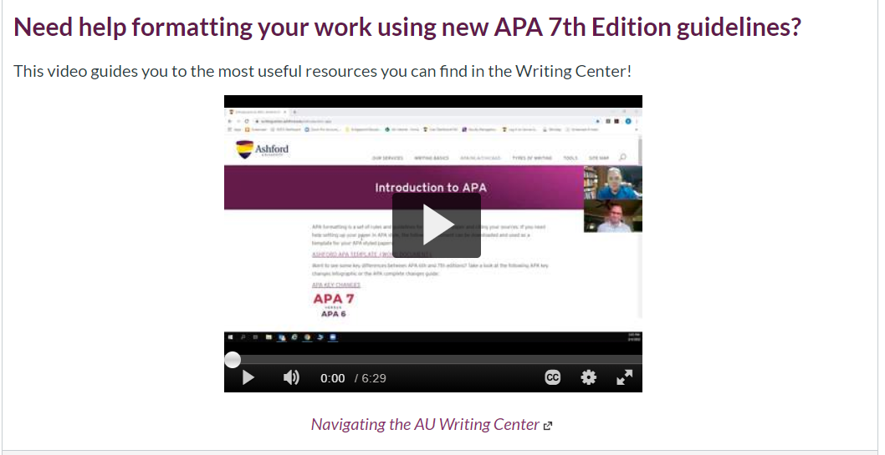

HTML Code for the Announcement:
<h3><strong>Need help formatting your work using new APA 7th Edition guidelines?</strong></h3>
<p>This video guides you to the most useful resources you can find in the Writing Center!</p>
<p style="text-align: center;"><iframe id="kaltura_player" title="Kaltura Player" src="https://cdnapisec.kaltura.com/p/1501441/sp/150144100/embedIframeJs/uiconf_id/24035961/partner_id/1501441?iframeembed=true&amp;playerId=kaltura_player&amp;entry_id=0_mwt6arzr&amp;flashvars[localizationCode]=en&amp;flashvars[leadWithHTML5]=true&amp;flashvars[sideBarContainer.plugin]=true&amp;flashvars[sideBarContainer.position]=left&amp;flashvars[sideBarContainer.clickToClose]=true&amp;flashvars[chapters.plugin]=true&amp;flashvars[chapters.layout]=vertical&amp;flashvars[chapters.thumbnailRotator]=false&amp;flashvars[streamSelector.plugin]=true&amp;flashvars[EmbedPlayer.SpinnerTarget]=videoHolder&amp;flashvars[dualScreen.plugin]=true&amp;flashvars[Kaltura.addCrossoriginToIframe]=true&amp;&amp;wid=0_dulec35u" width="400" height="285" sandbox="allow-forms allow-same-origin allow-scripts allow-top-navigation allow-pointer-lock allow-popups allow-modals allow-orientation-lock allow-popups-to-escape-sandbox allow-presentation allow-top-navigation-by-user-activation" allowfullscreen="allowfullscreen" webkitallowfullscreen="webkitallowfullscreen" mozallowfullscreen="mozallowfullscreen" allow="autoplay *; fullscreen *; encrypted-media *"></iframe></p>
<p style="text-align: center;"><a href="https://ashford.mediaspace.kaltura.com/media/t/0_mwt6arzr" target="_blank" rel="noopener"><em>Navigating the AU Writing Center</em></a></p>

Need help posting the HTML code? Watch this helpful video!

