World Central Kitchen, Eat. Learn. Play. Partners with the Colleges of Peralta Community College District
In response to dramatically increased food insecurity from the COVID-19 pandemic, colleges within the Peralta Community College District have forged partnerships with two nonprofits – Oakland’s Eat. Learn. Play. Foundation and the World Central Kitchen – to provide thousands of meals to students at three of the four colleges (with the fourth in progress). The Eat. Learn. Play. Foundation underwrites the cost of the meals, while the World Central Kitchen helps provide food delivery and distribution logistics. LaNiece Jones, Executive Director of the Peralta Colleges Foundation, played a crucial role in connecting the colleges with the Eat. Learn. Play. Foundation and their food distribution partner, the World Central Kitchen.

Eat. Learn. Play. Foundation
https://eatlearnplay.org/

Stephen and Ayesha Curry’s Eat. Learn. Play. Foundation is committed to unlocking the amazing potential of every child by fighting to end childhood hunger and ensuring children have access to nutritious food, establishing that students have access to a quality education, and the resources to succeed, and providing opportunities and safe places for all children to play and be active.

One in six kids in the United States, and one in four kids in the Bay Area, is affected by hunger. To compound the problem, families struggling with poverty often rely on fast food that lacks nutritional value, further contributing to our obesity epidemic. Both hunger and obesity take a profound toll on kids’ health, happiness and ability to be successful in the classroom. When kids get the nutritious food they need, they feel better, learn more and grow up stronger.

Eat. Learn. Play. is committed to ensuring every Oakland resident has the food they need for the duration of the COVID-19 crisis. Working alongside our key partners - including Oakland Unified School District, Alameda County Community Food Bank, and World Central Kitchen - the Foundation will help provide nearly 300,000 meals a week to Oakland residents over the next several months.

World Central Kitchen (WCK)
https://wck.org/

Founded in 2010 by Chef José Andrés, World Central Kitchen (WCK) uses the power of food to heal and strengthen communities through times of crisis and beyond. WCK has transformed the field of disaster response to help devastated communities recover and establish resilient food systems. Since its founding, WCK has served over 19 million meals to those impacted by natural disasters and other crises around the world in countries including Albania, The Bahamas, Colombia, Guatemala, Haiti, Mexico, Mozambique, Spain, Venezuela, and the United States.
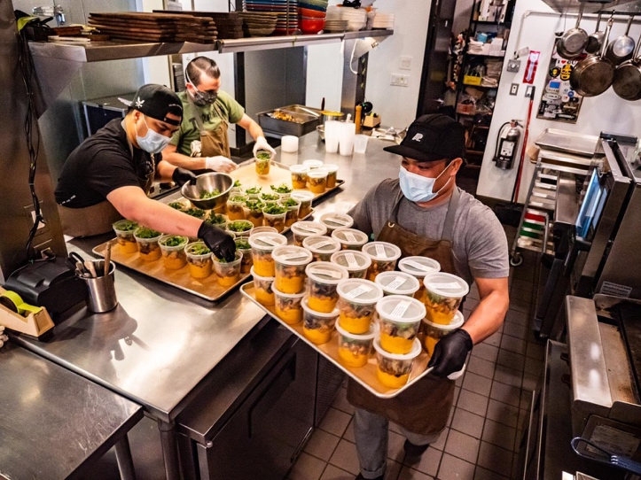
About WCK's COVID-19 Relief Efforts
World Central Kitchen is a team of food first responders, mobilizing with the urgency of now to get meals to those who need them most. We're activating hundreds of restaurants and kitchens to feed marginalized and vulnerable communities and our brave medical professionals on the front lines, in order to make a meaningful impact in the fight to keep everyone fed, and to support the distressed restaurant industry. We know that a nourishing meal in a time of crisis is so much more than a plate of food---it's hope, it's dignity, it's a sign that someone cares about you and that you are not alone.

Eat. Learn. Play. Together with World Central Kitchen

Eat. Learn. Play is working alongside World Central Kitchen in Oakland to engage 20-25 local restaurants in the preparation and distribution of up to 5,000 meals each day to Oakland's most vulnerable residents, including low-income children and families, the homeless, immigrants, youth in the foster system, the elderly, and health care and other essential workers on the frontlines of the COVID-19 crisis.

Laney College Partnership with Eat. Learn. Play. and World Central Kitchen

In early April 2020 the Peralta Colleges Foundation Director, LaNiece Jones, connected the Laney College President, Dr. Tammeil Gilkerson, with José Corona from the Eat.Play.Learn Foundation to discuss an opportunity for partnership around the Foundation’s goal to ensure every Oakland resident has the food they need for the duration of the COVID-19 crisis.

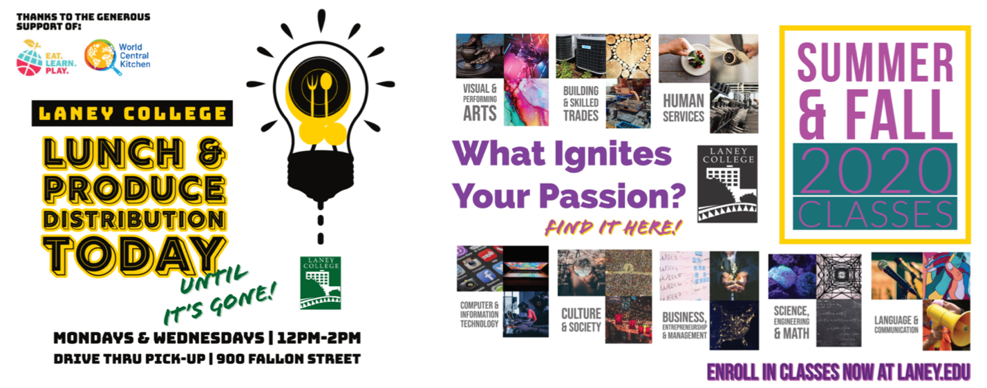

President Gilkerson worked with José to discuss Laney’s efforts around combating food insecurity and secured support to fund bi-weekly food distribution to Laney College students in partnership with the World Central Kitchen. WCK is working across America to safely distribute individually packaged, fresh meals in communities that need support – for children and families to pick up and take home, as well as delivery to seniors who cannot venture outside. Activating local restaurants to meet this demand, WCK is committed to their #ChefsForAmerica program by making key connections between people who need meals and restaurant workers and drivers who need to earn a living.

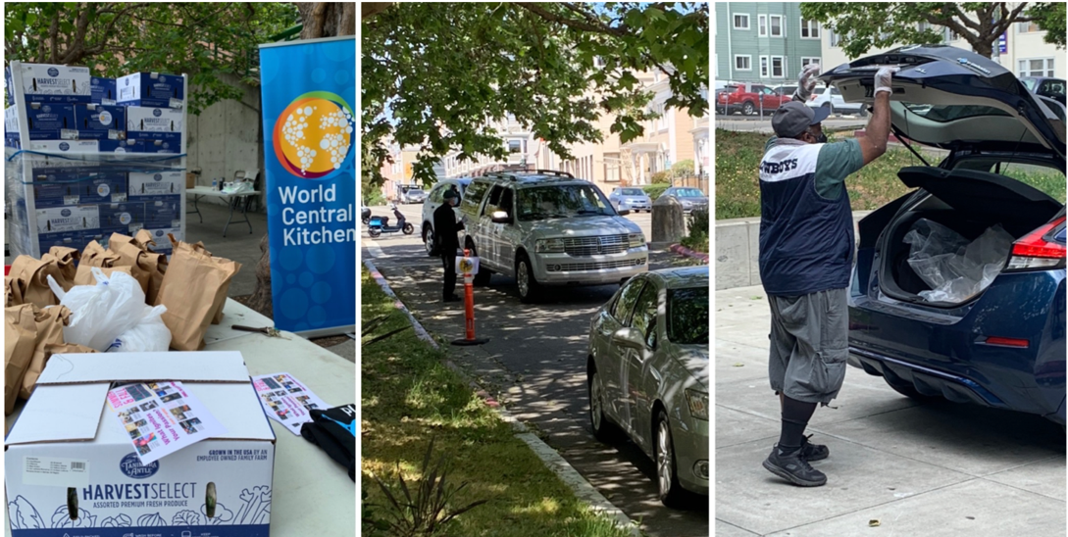

Since the end of April, Laney College has been working directly with the World Central Kitchen to distribute lunches on Mondays and Wednesdays from 12-2 pm with a walk-up and drive thru option.

Coordinated ably by Laney College’s Food Services Manager, Neil Burmenko, a team of five have been distributing food at each day while ensuring safety for students and the volunteers. The distribution team includes Beverly Bowes & Jacqueline Trotter, Culinary Arts Instructional Assistants; Alfred Brown, Food Services Supervisor; Neil Burmenko, Food Services Manager; and, President Gilkerson with support from Laney College custodians on the setup and takedown.

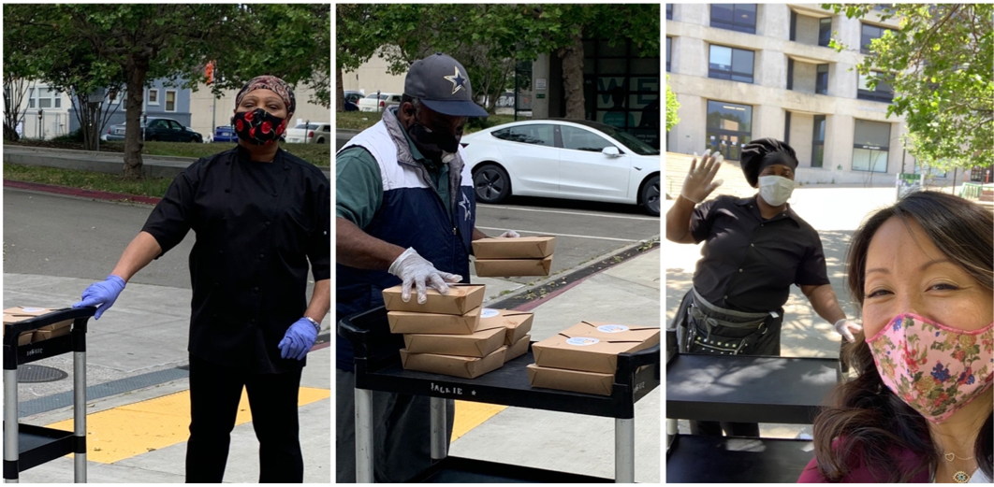

In May the distribution of fresh produce was also added to the lunch distribution. The College has distributed over 3,500 meals since the start of the partnership. Information encouraging enrollment in summer and fall classes has also been inserted into each produce box being distributed.

College of Alameda Partnership with Eat. Learn. Play. and World Central Kitchen

Based on the experience at Laney College, College of Alameda under the leadership of VPSS Tina Vasconcellos connected with World Central Kitchen to start deliveries to College of Alameda (CoA). CoA launched the “Grab.n.Go” lunches on Wednesday, May 6, 2020. CoA is the only distribution site in Alameda.

The “Grab.n.Go” lunch distribution takes place Monday, Wednesday, and Friday between 11:30 to 1:30pm. Each day 600+ meals are delivered to students and community. Beginning May 22, 2020, the program is being expanded to distribute product boxes on Fridays, in addition to the meals.

World Central Kitchen’s Restaurants for the People program is dedicated to tackling these crises on two fronts – at the same time providing fresh meals to communities in immediate need while also keeping small restaurants and food businesses open.

Restaurants for the People meets need on two crucial fronts – buying meals directly from restaurants and delivering them to Americans who need help.
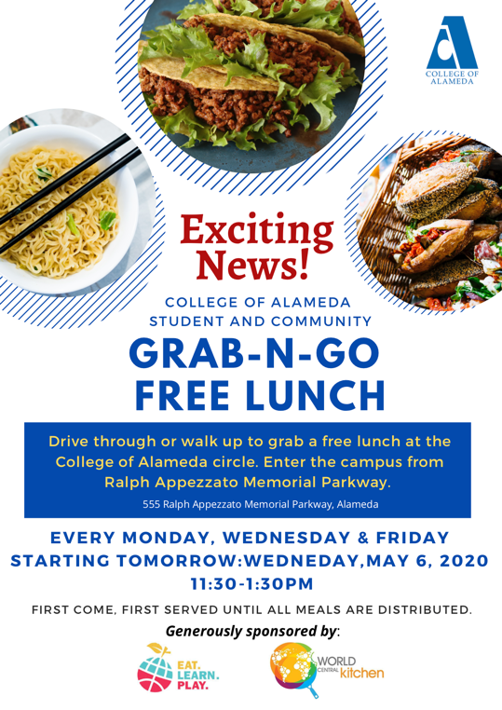
How it works
- WCK is working closely with community and government leaders and organizations around the country to identify local food and nutrition needs.
- WCK identify restaurants – small, independent, and community-focused – and bring them into the WCK network, including sharing nutritional guidelines, health and safety expectations, and cultural sensitivities.
- WCK has mapped out a delivery system to match restaurants with community need, including working safely with delivery companies, furloughed government workers, and volunteers.
- WCK are ensuring weekly revenue for each restaurant, which enables them to re-hire workers and continue buying from local farmers, suppliers, and producers – not to mention paying rent and keeping the lights on.

The program at CoA is underwritten by Eat. Learn. Play. who pays participating restaurants approximately $10 per meal.

Merritt College Partnership with World Central Kitchen and Eat. Learn. Play.

Merritt College is excited to begin working with the Eat. Learn. Play. Foundation and the World Central Kitchen to help address the needs of East Oakland residents during this challenging time. In April 2020 LaNiece Jones, the Peralta Community College District Foundation Executive Director, connected Merritt College Leadership with Stephen and Ayesha Curry’s Eat. Learn. Play. Foundation. The work of Eat. Learn. Play. focuses on ensuring that every child has access to three vital ingredients to a happy, healthy, and successful childhood: nutritious food, a quality education from early-childhood through college completion, and the opportunity to play and be physically active. According to Jose Corona, who heads Programs & Partnerships for Eat. Learn. Play. “Peralta does an amazing job of serving young adults in Oakland, and we want to make sure that we support the District in providing the community with the food support it needs.”

While Eat. Learn. Play. is responsible for underwriting the cost of the food from local restaurants, we are relying heavily on the support of World Central Kitchen to manage the delivery and distribution logistics. World Central Kitchen is a global, non-profit organization committed to creating smart solutions to hunger and poverty. They are particularly present and effective in the aftermath of natural (and at times man-made) disasters, providing food and relief to those most in need around the world. In the past several months, World Central Kitchen has been active in communities across this country, helping to distribute safe and essential meals, and by extension, supporting small restaurants that provide the meals we will serve.

Merritt College’s first “Grab and Go Pop Up,” is scheduled for Thursday, May 28th from 12pm to 2pm. We will set up at the David E Glover Education & Technology Center, located at
6948 Foothill Blvd (right across from Eastmont Mall parking lot). We are making a conscious decision to hold this first event in the heart of the community rather than up in the hills on our campus, and for our maiden voyage we are planning to distribute 350 lunches to community members. We will also provide Merritt packets that contain class schedules, program brochures, registration materials, and a flyer describing the Merritt College Chromebook lending program. President David M. Johnson, Vice President of Student Services Lilia Chavez, Director of Student Activities and Campus Life Doris Hankins, and our Community Outreach Specialist Maria Spencer will be on site to pass out meals and distribute materials (with everyone adhering to social distancing protocols).

Berkeley City College and World Central Kitchen Update

Berkeley City College provides basic food support for students via our partnership with the Berkeley Food Network and the Alameda Food Bank, both for over two years. Since early April and during COVID-19 shelter-in-place orders, we have served over 350 students, averaging 75+ students who receive grocery bags at the Berkeley Food Network Warehouse (located at 9th and University Avenue) each week. This distribution is in additional to the regular distribution to Albany and Berkeley residents each month. This results in BCC students having up to six days per month when they can receive groceries.

The connections for World Central Kitchen food distribution was primarily focused on Oakland residents due to their partnership with “Eat. Learn. Play. Foundation.” BCC has 27% (n=1176) students who are Oakland residents. This is the criterion required by the Eat. Play. Learn Foundation, which funds meals from World Central Kitchen.

Our goal is to secure BCC as an additional site for students to access the prepared meals from World Central Kitchen. LaNiece Jones of the Peralta Foundation is the broker for this partnership with the other colleges, as she has the connection to the Eat. Play. Learn Foundation. She is our main contact for connecting with them and identifying location requirements for food distribution at BCC. We are prepared to connect with Berkeley High School or UC Berkeley for use of larger spaces, such as a field or parking lot, to address healthy and safety for distribution. LaNiece has been instrumental in helping Laney College, College of Alameda, and Merritt College to secure the prepared meals for students. And she is working with VP Stacey Shears to confirm connection with BCC. This assistance would supplement the groceries from the Berkeley Food Network.

Thank you to the contributors of this report - Mark Johnson, Interim Director - Marketing, Communications, Public Relations -Dr. Angelica Garcia, President, Berkeley City College -Dr. Tammeil Gilkerson, President, Laney College - Dr. David Johnson, President, Merritt College - Dr. Tim Karas, President, College of Alameda

