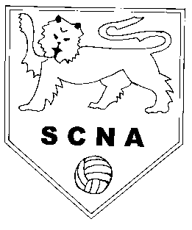 | Surrey County Netball Association  carol.mcgrail@virginmedia.com

Award Criteria
- Presented to a netball club who has made an outstanding contribution within their community
- Nominated clubs must be affiliated to England Netball and hold a current CAPS award
- Nominated clubs must have been active for a minimum of 3 years
- Nominated clubs should have made a particular impact between 1st April 2018 and 31st March 2019

Completing the Nomination Form
All fields must be completed on the nomination form, additional documents submitted will not be considered.

Each nomination is to be accompanied by two high resolution images (jpeg or png file format). One action and one portrait image if possible.

Utilise the word limit, it is important to be succinct. Ensure you have specific, appropriate and precise information about the nominee.

Write short sentences that are concise and give specific detail. Avoid praising adjectives. List the most important information in the first few sentences, and then elaborate as necessary.

Do not include information that is not relevant to the category. For example, the nominees playing history is not relevant and will be disregarded.

If a club has been nominated in a previous year they are still eligible for this year’s award so you can nominate them again.

Impact – please include specific examples, numbers and anecdotal evidence.

Typed nomination forms are preferred however if submitting a hand written nomination use black ink and write or print as clearly as possible.

Surrey County Netball Association
carol.mcgrail@virginmedia.com

Nominee Information
Club Name
Region |  | L&SE/Surrey
Contact Address
Contact E-mail Address
Contact Telephone Number
Date Founded
Affiliation Number (must be included)
Nominator Information
Name
Address
E-mail Address
Telephone Number
Relationship to Nominee
Club Details
UKCC Level 1
UKCC Level 2
UKCC Level 3
Beginner/ Youth Award Umpires
C Award Umpires
B Award Umpires
A Award Umpires
Pass on Your Passion Members
Youth Advisors
Senior Members
Junior Members (U18)
CAPS Level
Outstanding Competitive Achievements
Year | Competition |  | Level | Result

Does the club support any other volunteers?
In bullet points, please note what IMPACT the club has made over the past 12 months and what ACHIEVEMENTS they have contributed to (300 Words)
What makes your nominated netball club outstanding? (200 words)
How has the club encouraged others to participate in netball and join the netball family? (200 words)

