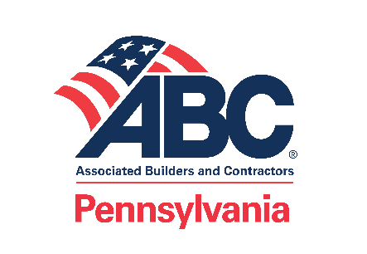
ABC Legislative Office
800 North Third Street, Suite 407
Harrisburg, PA 17102
abcpa.org

February XX, 2021
The Honorable [First Name] [Last Name]
Address
Washington, D.C. [ZIP]
Dear Congressman [Last Name]:
The Associated Builders and Contractors of Pennsylvania (ABC of Pennsylvania) board of directors voices our strong opposition to H.R. 842, the “Protecting the Right to Organize Act.” According to House Majority Leader Steny Hoyer (D-MD-5), the full House is expected to vote on the bill the week of March 8.
If enacted, the legislation would not “protect rights.” In fact, the bill constricts the rights of both employers and employees by making massive changes to established labor laws. For example, an employer’s right to communicate with their employees during the organizing process or to seek legal counsel would be severely restricted. The bill rips away the basic and fundamental right of privacy by requiring employers to provide employee contact information to union organizers, without approval from the employee. The bill goes farther by taking away individual rights and freedoms by forcing employees to join a union against their will. Surprisingly, the legislation would even make it difficult for an employee to leave a union if they believed the union did not adequately represent them.
ABC does NOT oppose unions and supports an employee’s right to voluntarily join a union if they so choose. While the legislation is intended to make it easier for unions to organize, we do not believe that is the appropriate role of government. Rather, we believe government should promote sound economic policies that encourages the private sector to grow, create jobs, and be innovative. We look forward to working with you to advance legislation in that regard.
Please understand that in the construction industry, employees who choose not to affiliate with a union make up over 87 percent of the workforce. ABC of Pennsylvania alone represents nearly 1,400 member companies and approximately 67,000 employees. We believe the concerns of our association, which represents such a significant portion of the workforce, deserves your attention.
Thank you for considering our views.
Sincerely,
Roger Brubaker Tom Kittredge
Meadow Valley Electric Kanawha Stone Company, Inc.
Ephrata, PA Poca, WV
Keystone Chapter Western Pennsylvania Chapter
Congressman [LAST NAME]
Page 2
DATE
Andy Michielli Bob Miller
Merit Electrical Group, Inc. Chronos Construction Staffing, Inc.
Oakmont, PA Hockessin, DE
Western Pennsylvania Chapter Eastern Pennsylvania Chapter
Matt Pincus Barbra Runyon
Pincus Elevator Company Brechbill & Helman Construction Company, Inc.
West Chester, PA Chambersburg, PA
Eastern Pennsylvania Chapter Cumberland Valley Chapter
Herb Sandifer James Stephens
Waynesboro Construction Company, Inc. Clark Associates, Inc.
Waynesboro, PA Lancaster, PA
Cumberland Valley Chapter Keystone Chapter
Paul Tomczuk
R.H. Marcon, Inc.
State College, PA
Central Pennsylvania Chapter
cc: U.S. Senator Bob Casey, Jr.
U.S. Senator Pat Toomey

Advocating for free enterprise and the merit shop philosophy throughout the Commonwealth.

